DAY 75 2 Azure Vm
Step 1: Creating the Virtual Machine
First, I logged into the Azure Portal and searched for Virtual Machines. Then I clicked on Create → Azure Virtual Machine.
- I created a new Resource Group named RG-VM-Assignment
- Set the Virtual Machine name as WinServer-Lab-01
- Selected Windows Server 2022 Datacenter: Azure Edition as the image
- Chose the size Standard_B2s, which is suitable for this lab
After that, I created an administrator username and a strong password.
In the Inbound Port Rules, I selected Allow selected ports and enabled RDP (3389) so I could access the VM remotely.

Step 2: Reviewing and Deploying
I kept the default settings for disks and networking. Azure automatically created the required virtual network and public IP address.
Then I clicked on Review + Create, and after validation passed, I clicked Create. The deployment took around a few minutes to complete.

Step 3: Connecting to the VM using RDP
Once the deployment was successful, I went to the VM resource page and clicked on Connect → RDP.
- I downloaded the RDP file
- Opened it and clicked Connect
- Entered the username and password I had created earlier
- Accepted the certificate warning
After that, I was able to successfully log in and access the Windows Server desktop.

3. Connection Proof
I took a screenshot after logging into the virtual machine. The screenshot clearly shows the Windows Server desktop with the Server Manager dashboard open.
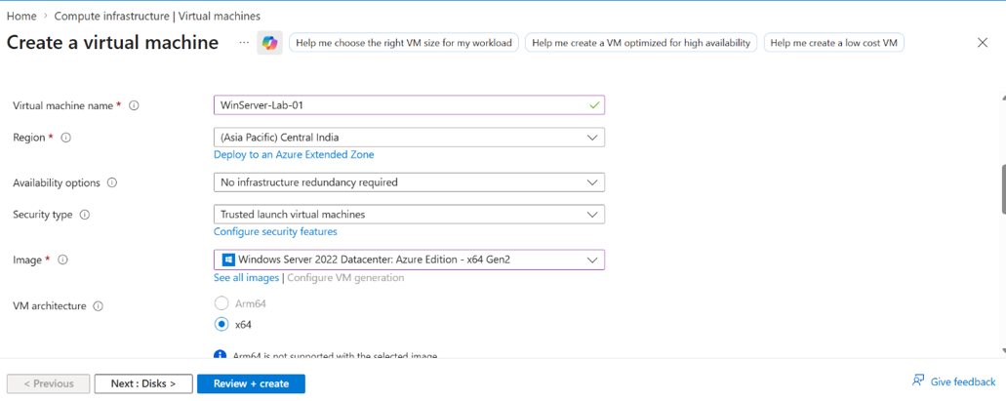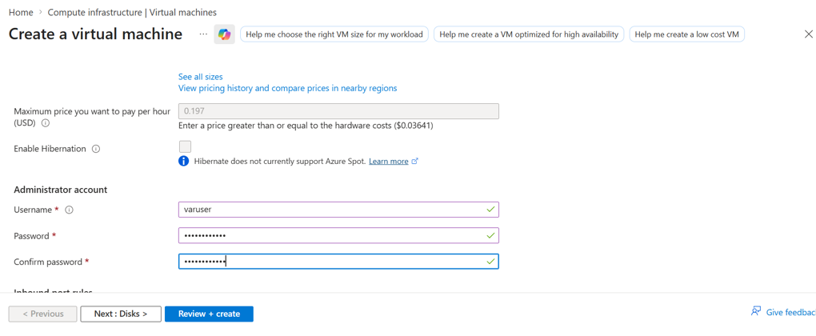
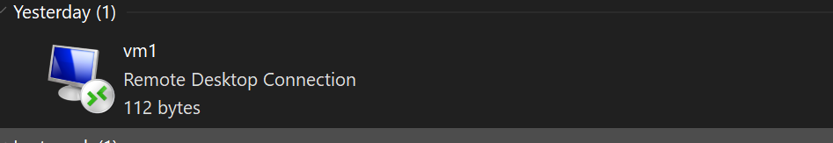

4. Resource Cleanup
After completing the assignment, I deleted the resources to avoid unnecessary charges.
- I went to Resource Groups
- Selected RG-VM-Assignment
- Clicked on Delete Resource Group
- Confirmed the deletion

